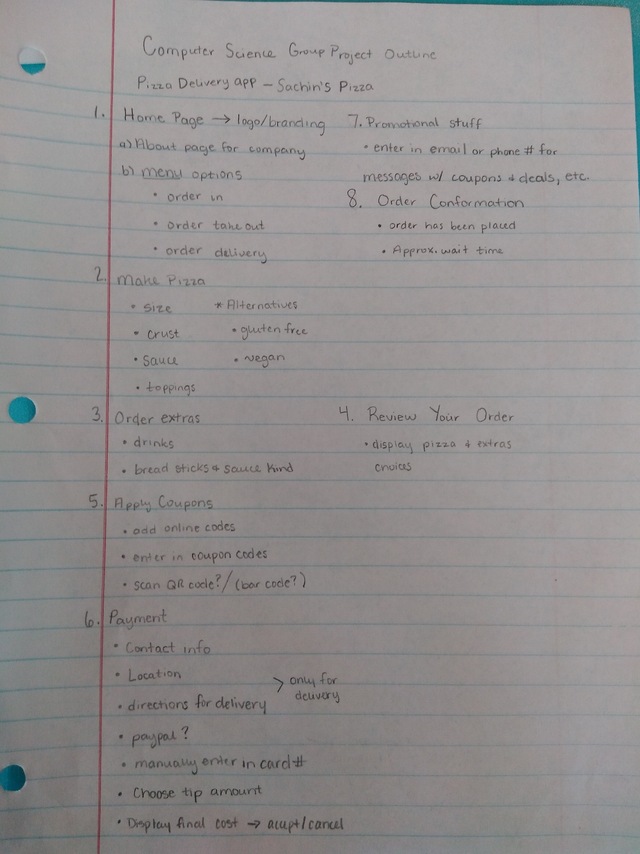

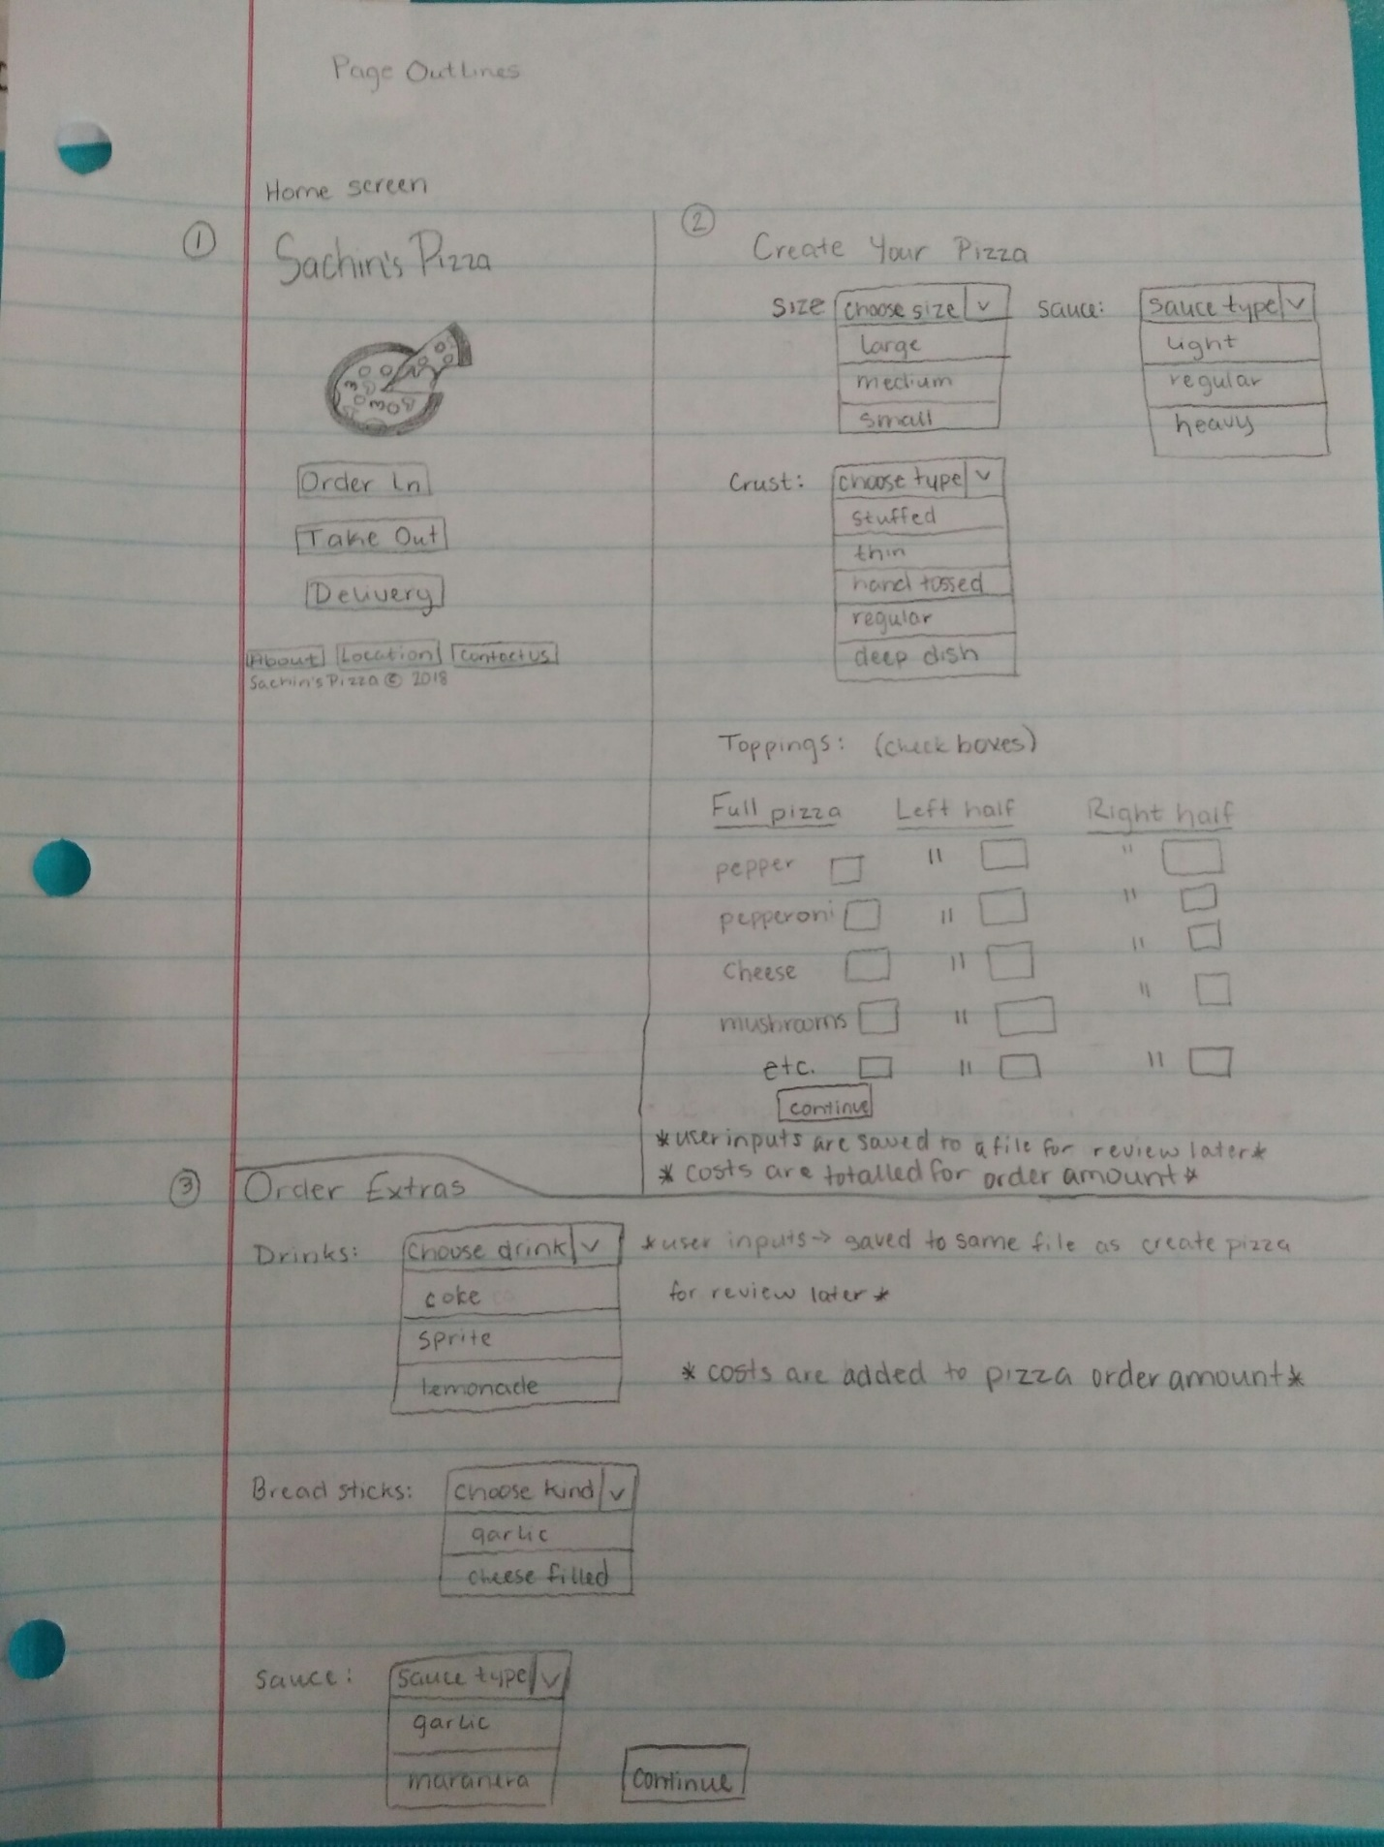

Build check box options as separate class to be called within jframe

Build drop down menus as separate class to be called within jframe

Build drop down menus as separate class to be called within jframe

orderAmount = toppingPrice +sizePrice;

\*use CSV file\*

.addExtra()

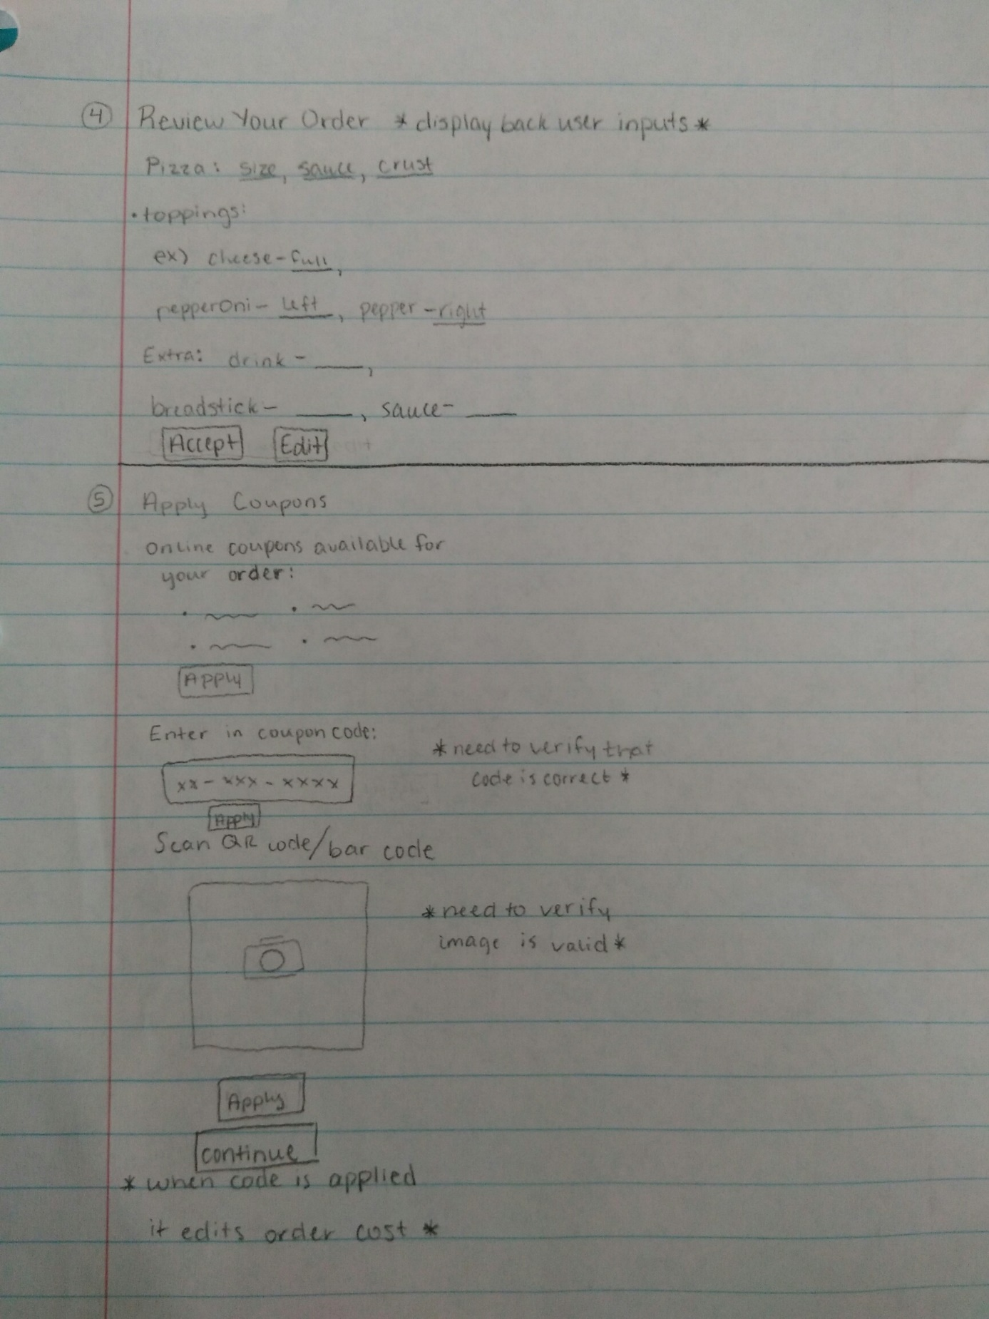

Tally up coupon price and wait to apply at end?

\*use CSV file\*

I don’t know if we’ll actually do the code scanner or not. I just think it would be cool to add if we could figure out how to do it

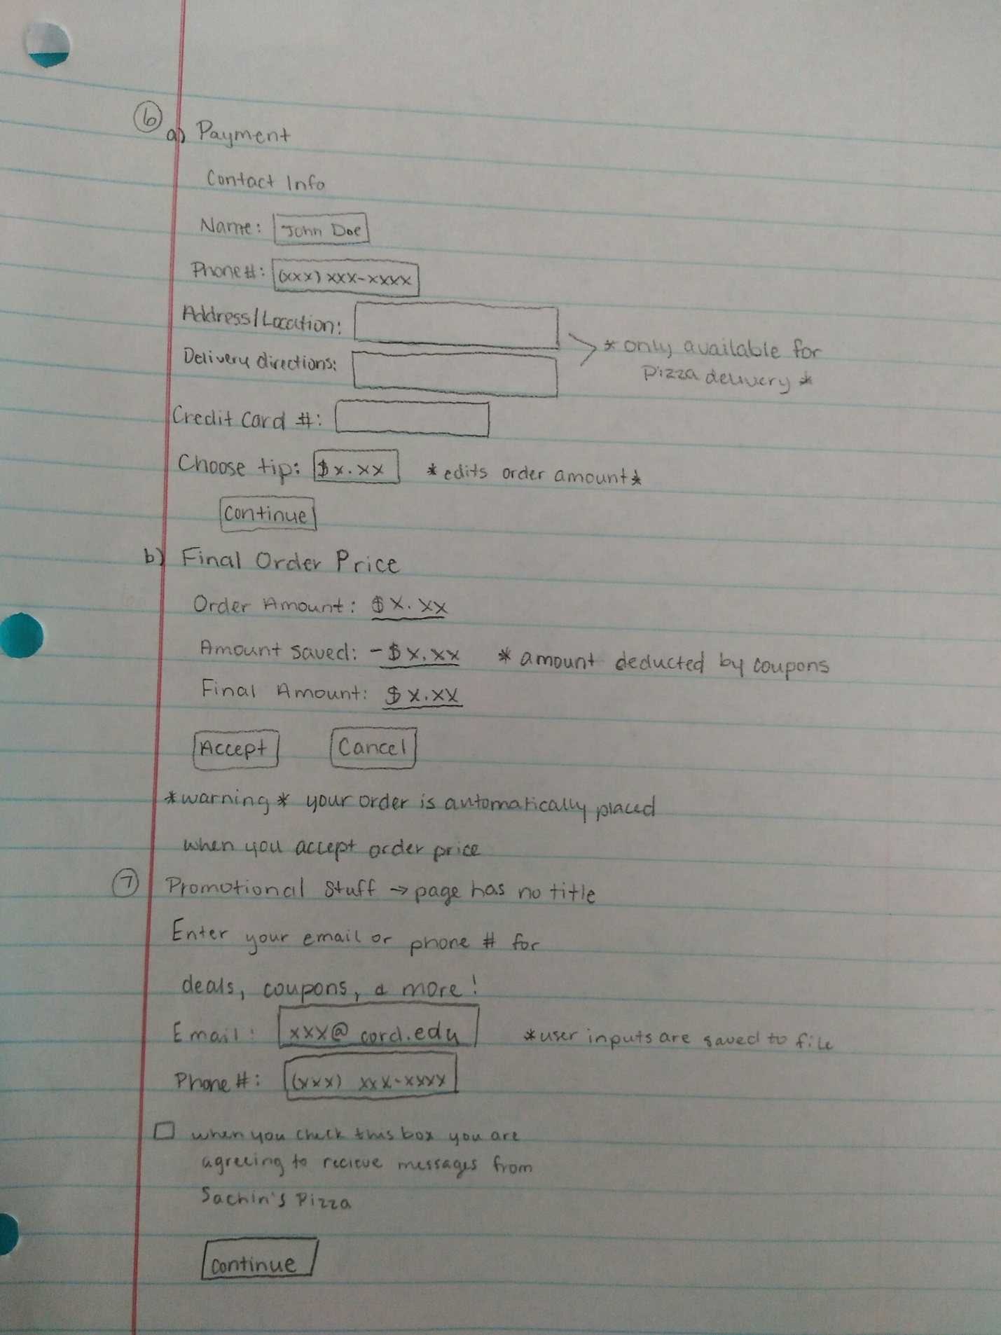

.deductSavings()

finalAmount = orderAmount – totalSavings;

.addTip()

